1.



2.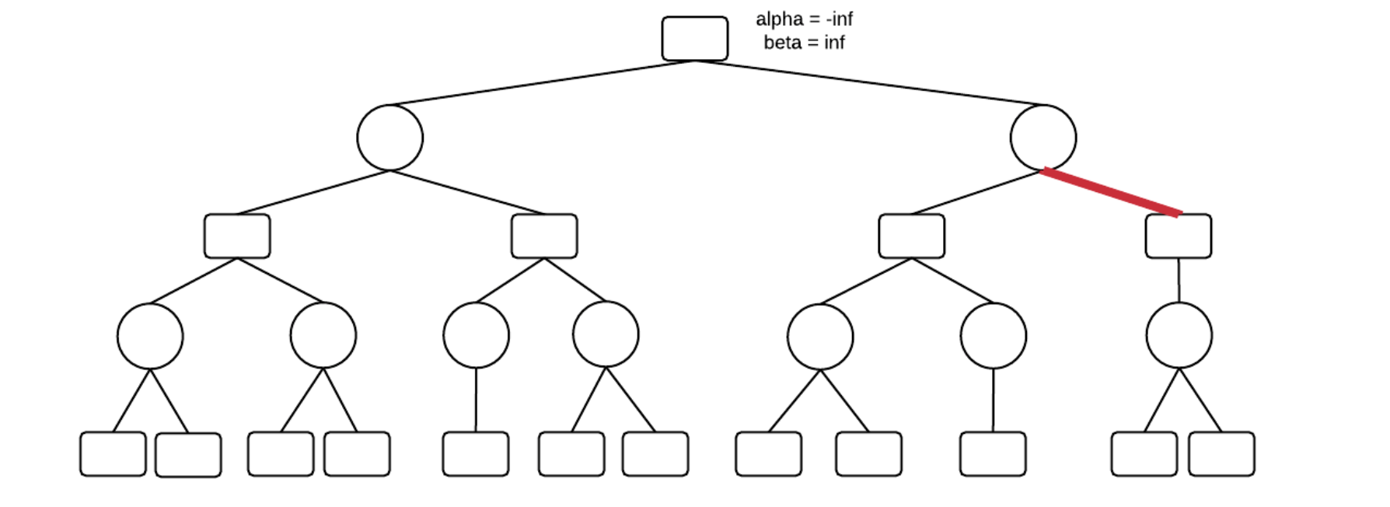

3 .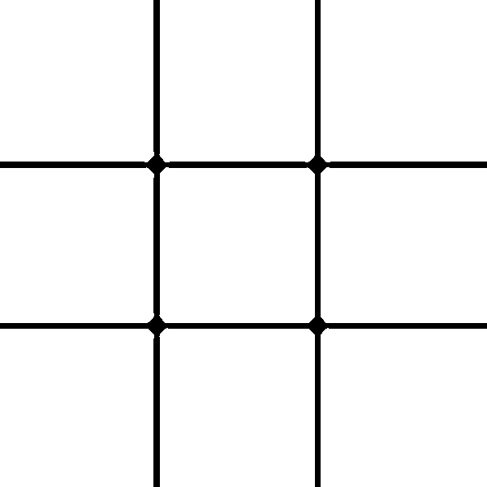

 

 

 

 

 

 

 

 

4 .

 

 

 

 

 

 

 

 

5. 

Using the tree from problem 1 (ignoring the alpha-beta pruning), even if MIN makes suboptimal decisions, MAX will do no worse. In this example, MIN will choose the higher value 50% of the time.